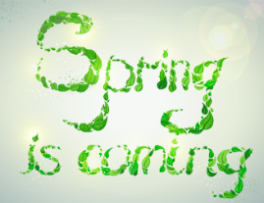A Preview of Coming and Past Attractions

## For the week of March 1st ~ 5th

**In Mrs. Schneider’s 5th Grade**

Scheduled Events & Reminders:

* Read Across America and Dr. Seuss week. Please see red note.
* Please check planners so you know what homework or completed papers you should be seeing. They should be showing you their papers and just a reminder they can redo them for half credit if they want.
* The end of the quarter is Monday, March 8th. Please check campus often.

Tests:

* Social studies chapter 10 test on Wednesday.
* Science unit 13 test on Thursday.
* Spelling – Vocab 2 and 3 completed by Friday, March 5th.

**What we’ve been studying:**

* *Holes* is the novel we began this week. We are reading some chapters together and they will have to complete some on their own. After each day, they need to answer comprehension questions on a worksheet in complete sentences. Writing complete sentences have been hard for some as they tend to leave out the subject of the sentences. We will be reading around 20 pages a day. Each night have your child tell you about the chapters we read that day to help them with retell skills as well as comprehension. They are really enjoying the book so far!!
* Topic 12 is over measurement. This week we learned about customary units of length and capacity.
* Spelling is only vocab and there are 2 different lists that will need to be done.

